# #4 A common habit among most entrepreneurs

### that is not talked about enough



[Smoul](https://notaprodigy.beehiiv.com/authors/b714c51d-eaa0-4a05-9f33-0c014aaa95e1)  
August 12, 2023

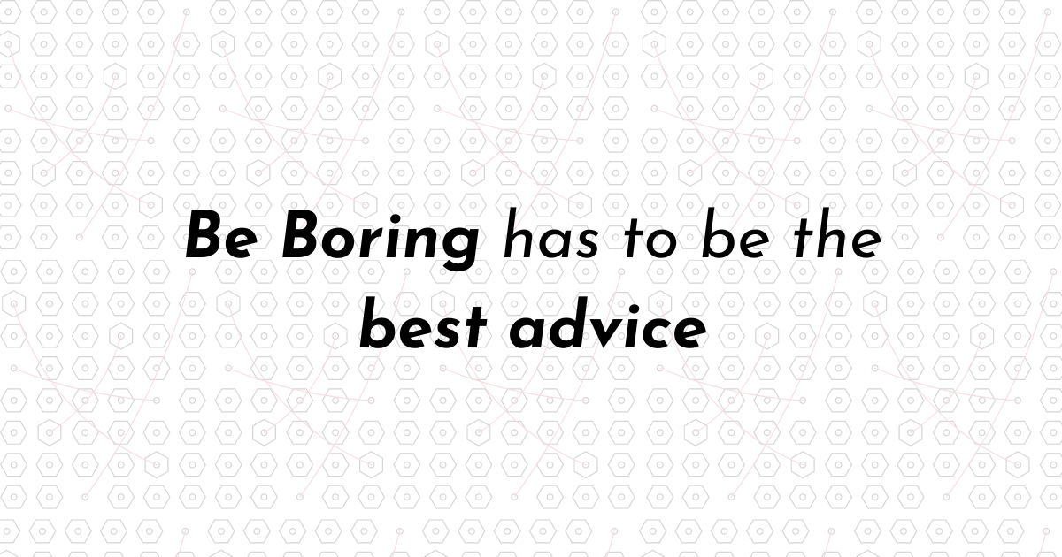

**Read Time: 1 min 30 seconds**

Being boring is my lifestyle by choice.

I have 5 friends whom I meet once in 10 days. [When they convince me that I need to step out in the sun]

I sit with my family and take out time for them.

I silently go on trips once a month because I promised myself I’ll start living my life and not sit in front of a study desk for 14 hours a day.

I don’t create drama or make enemies.

Being unproblematic has to be one of the best traits.

The secret?

#### You need the energy to be creative.

90% of creative people I know are silent observers. They have a notebook or a digital archive where they store all their ideas and review them frequently.

Artists choose to take a walk outside, be inspired by the whistling of trees, and look at people trying to hide in the crowd.

Entrepreneurs like listening to people. And not just for the sake of listening, but to understand what they’re saying. They suck the problem from the statement and build to solve it.

Becoming observant and creating an idea archive is the most effective strategy to never run out of ideas and always remain creative.

To be this observant, you need to become one with the surroundings. Be boring.

#### But how exactly will a digital archive help?

It will not just help, it will create. Just like you schedule future events in google calendar to be reminded of upcoming tasks, you need a log of past events too.

It does not have to be a journal or a diary. It should not have a format too. It just needs to make sense.

In this archive, write all the projects you are working on. The accomplishments you’ve had and the things that inspire you.

Write down quotes that you need to be reminded of and also write the ideas that don’t work out. Make a big fat logbook of things that make you - **YOU**

This method has helped me escape writer’s block and never run out of ideas. When I am in that state, I look up at my past projects, see what I can improve in them, and then boom - you have an entirely new project.

#### What to do next?

* Take a small notebook if you prefer writing or create a Notion page - name it “My Archive”
* Write as much of your past projects or ideas as you remember. Don’t stress about the page looking pretty yet
* Gather things that motivate you and start embedding them in your dashboard.
* Now keep it safe, and update it as frequently as possible. [I update mine every 3 days]

See you again  
Smoul  
[The Queen of Adventurous Boring People]

I did not forget the deal. This week I'm offering 50% off on all products - including the Naval Rakiant Mental Model's pack.

Make sure to use the code 'IMSEXC' on my Gumroad stote [link below] and avail all the products at the best price!